**Project Title**

**Optimizing User, Group, and Role Management with**

**Access Control and Workflows**

**Team Id: NM2025TMID15734**

**Team Members: 5**

**Team Leader : VELAVAN P**

**Team Member 1: HARIDOSS V**

**Team Member 2: HARISHKUMAR M**

**Team Member 3: JAYAVARTHANA V**

**Team Member 4: KAVIYARASU R**

**Problem Statement:** In a small project management team consisting of a Project Manage (Alice) and a Team Member (Bob), there is a need to efficiently manage project tasks and ensure accountability throughout the project lifecycle. The current system lacks clear role definitions, access controls, and a structured workflow, leading to confusion regarding task assignments and progress tracking.

**Objective:**

1. **Define User Roles Clearly:** Establish distinct roles for Alice (Project Manager) and Bob (Team Member) to ensure clarity in responsibilities and access rights within the project management tool.
2. **Implement Access Control Mechanisms:** Create a system that restricts Bob’s access to project creation and editing features while allowing him to view and update his assigned tasks, thereby preventing unauthorized changes.
3. **Streamline Workflow Processes:** Develop a structured workflow for task assignment and progress tracking, ensuring that Alice can easily assign tasks to Bob and monitor their completion in a timely manner.

**Skills:** Users, Groups, Roles, Tables, Access Control List, Flow Designer

.

**TASK INITIATION**

**Milestone 1 : Users** **Activity 1: Create Users**

* 1. Open service now
  2. Click on All >> search for users
  3. Select Users under system security
  4. Click on new
  5. Fill the following details to create a new user
  6. Click on submit

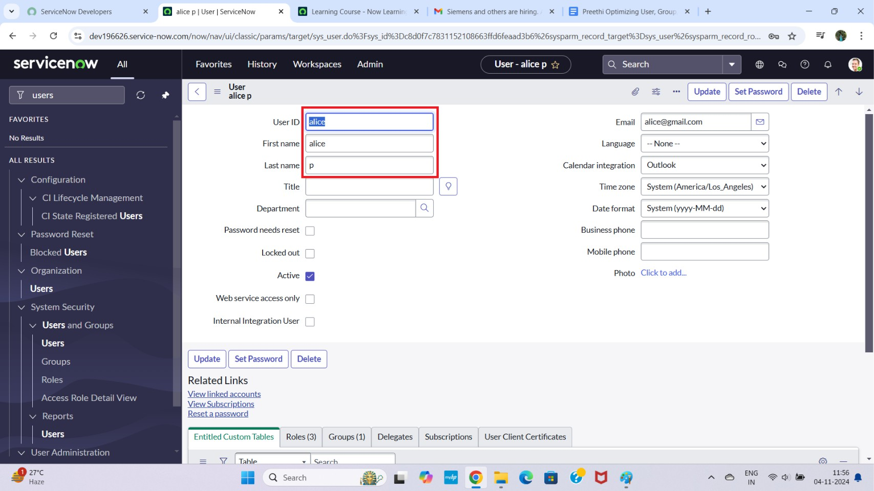

### Create one more user:

* 1. Create another user with the following details
  2. Click on submit

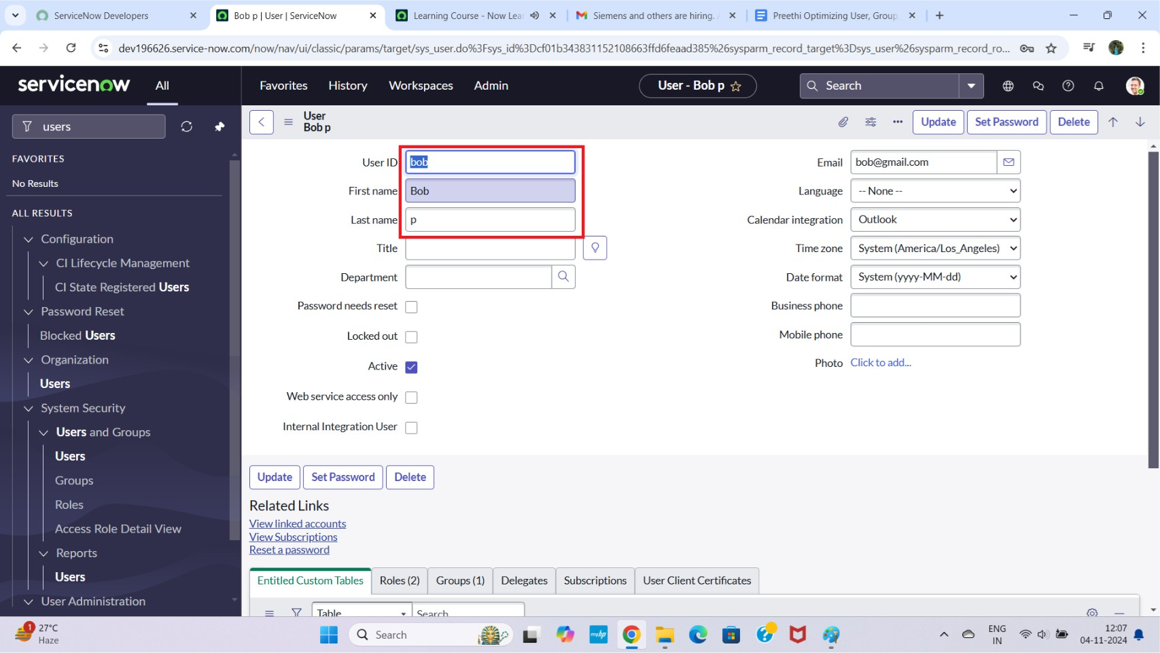

## Milestone 2 : Groups Activity 1: Create Groups

1. Open service now.
2. Click on All >> search for groups
3. Select groups under system security
4. Click on new
5. Fill the following details to create a new group
6. Click on submit

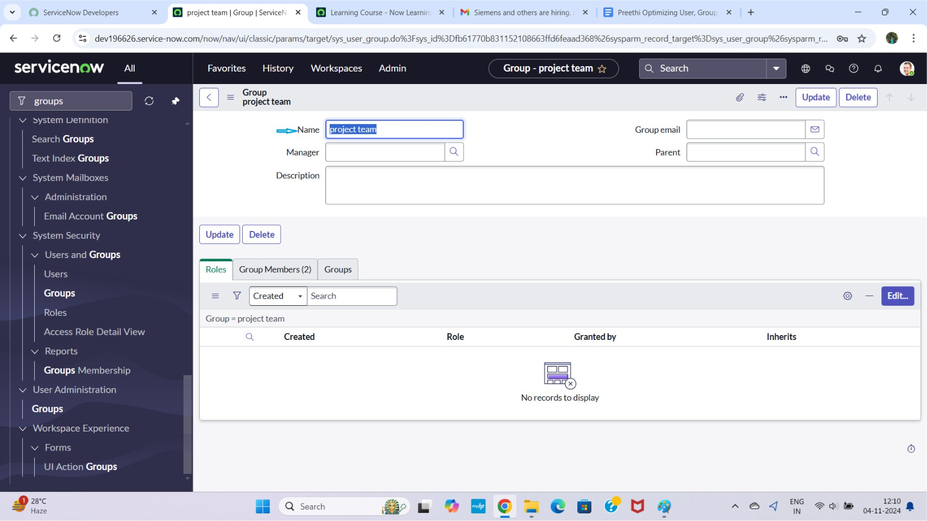

## Milestone 3 : Roles Activity 1: Create roles

1. Open service now.
2. Click on All >> search for roles
3. Select roles under system security
4. Click on new
5. Fill the following details to create a new role
6. Click on submit

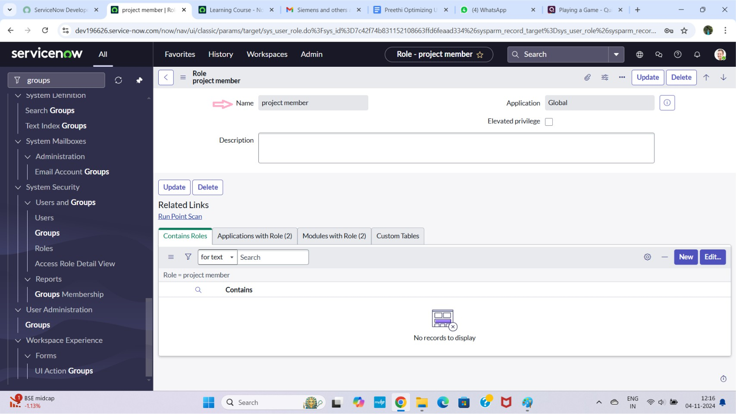

### Create one more role:

1. Create another role with the following details
2. Click on submit

## Milestone 4 : Table

**Activity 1: Create Table**

1. Open service now.
2. Click on All >> search for tables
3. Select tables under system definition
4. Click on new
5. Fill the following details to create a new table Label : project table

Check the boxes Create module & Create mobile module

1. Under new menu name : project table
2. Under table columns give the columns

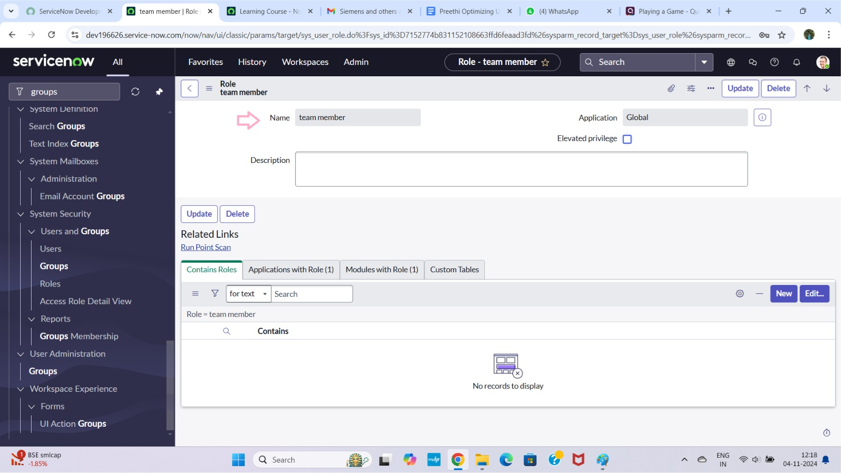

1. Click on submit

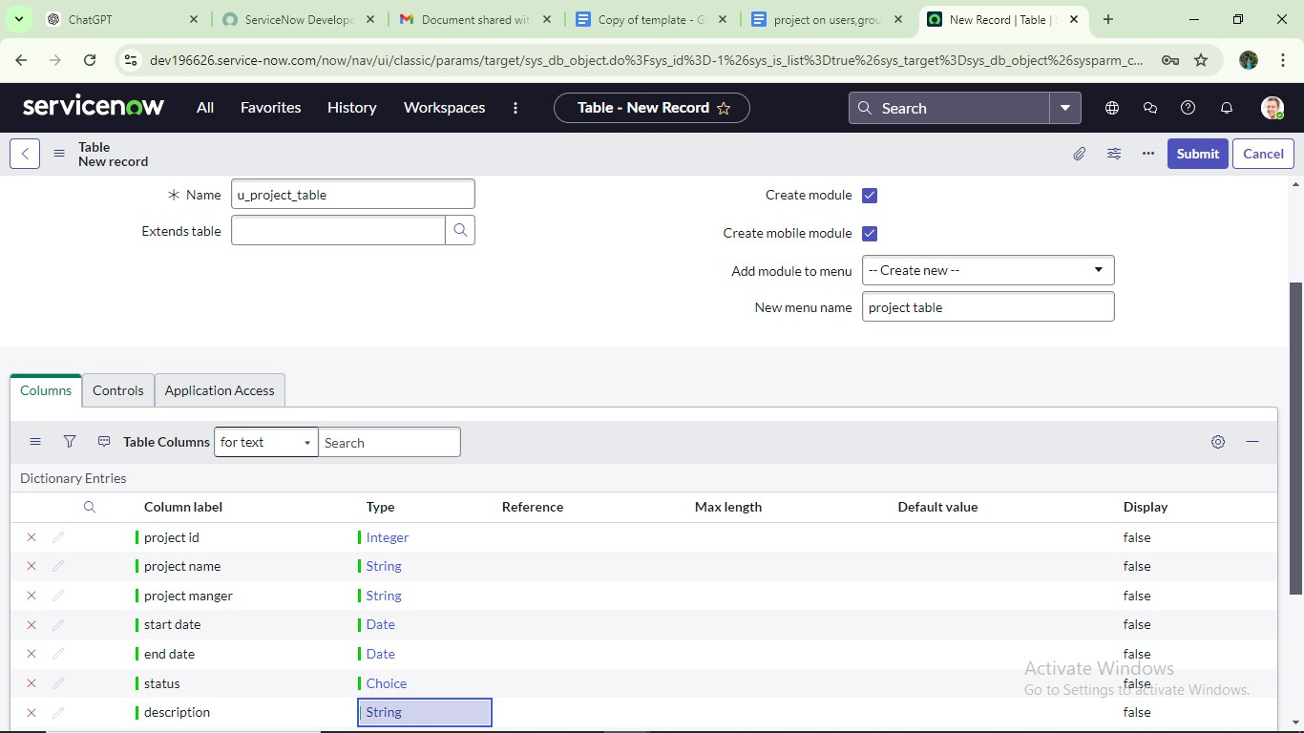

### Create one more table:

1. Create another table as:task table 2 and fill with following details.
2. Click on submit.

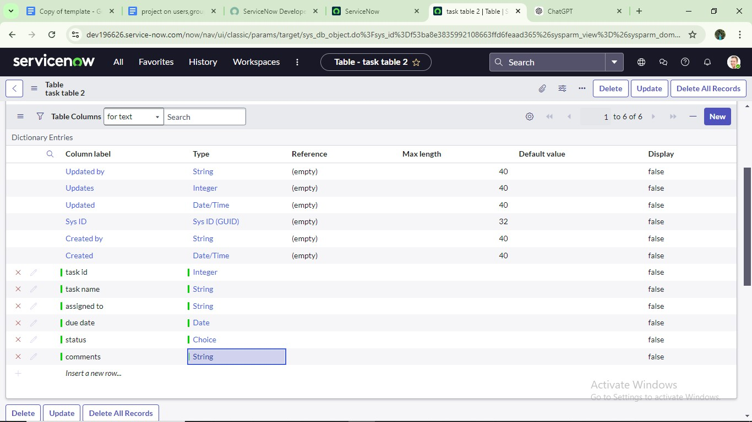

## Milestone 5 : Assign users to groups

**Activity 1: Assign users to project team group**

* 1. Open service now.
  2. Click on All >> search for groups
  3. Select tables under system definition
  4. Select the project team group
  5. Under group members
  6. Click on edit
  7. Select alice p and bob p and save

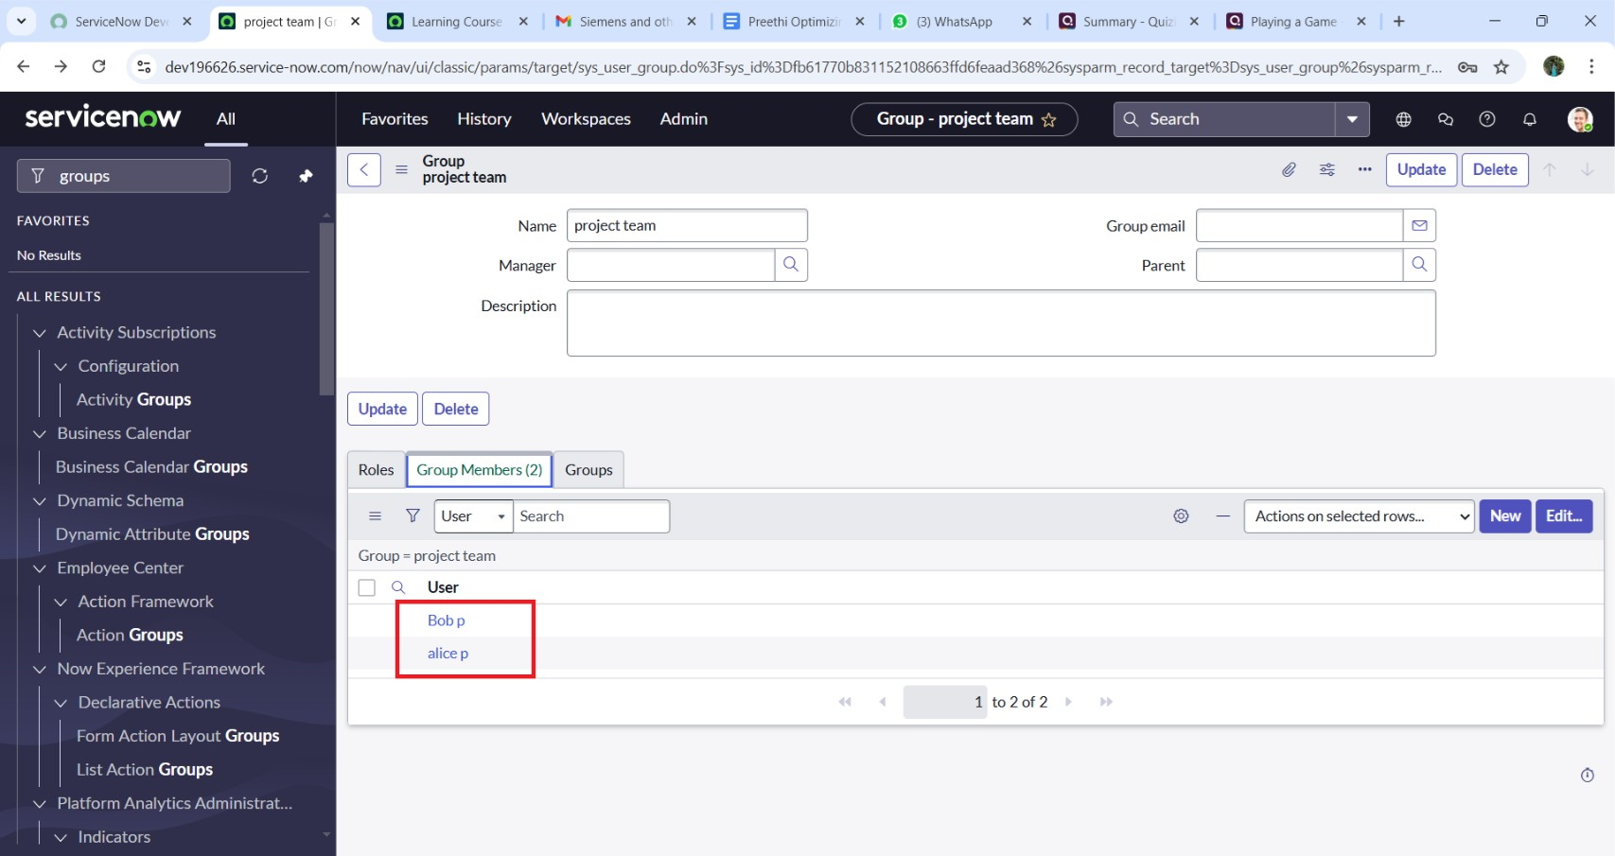

## Milestone 6 : Assign roles to users Activity 1: Assign roles to alice user

1. Open servicenow.Click on All >> search for user
2. Select tables under system definition
3. Select the project manager user
4. Under project manager
5. Click on edit
6. Select project member and save
7. click on edit add u_project_table role and u_task_table role
8. click on save and update the form.

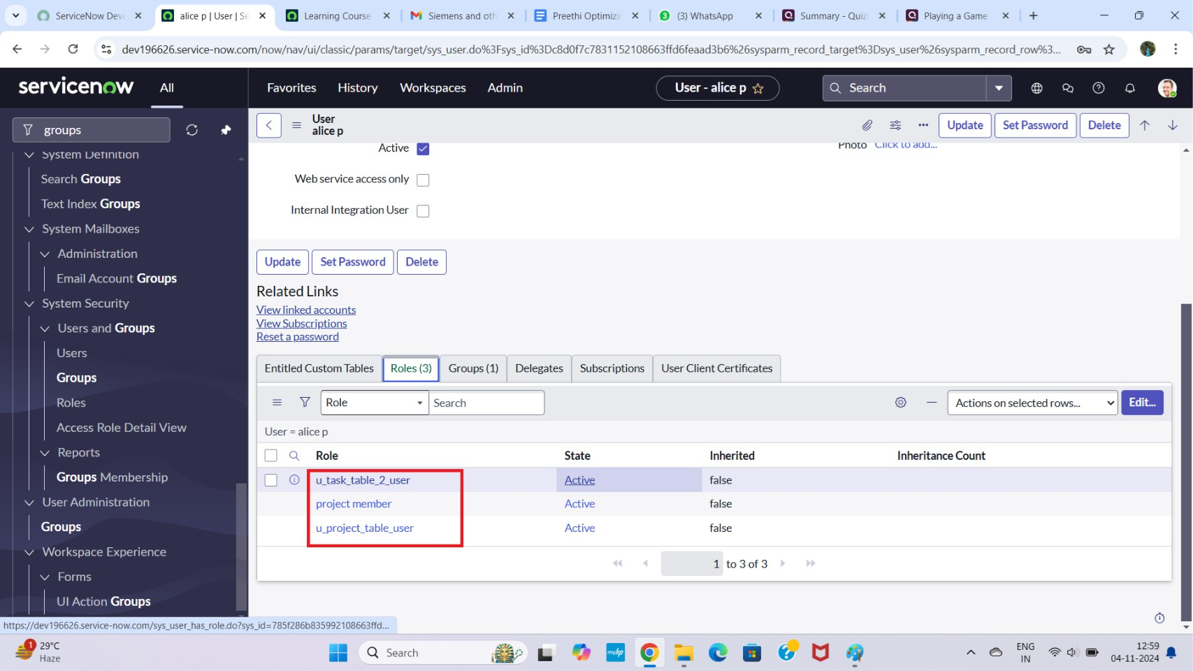

## Activity 2: Assign roles to bob user

1. Open servicenow.Click on All >> search for user
2. Select tables under system definition
3. Select the bob p user
4. Under team member
5. Click on edit
6. Select team member and give table role and save
7. Click on profile icon Impersonate user to bob
8. We can see the task table2.

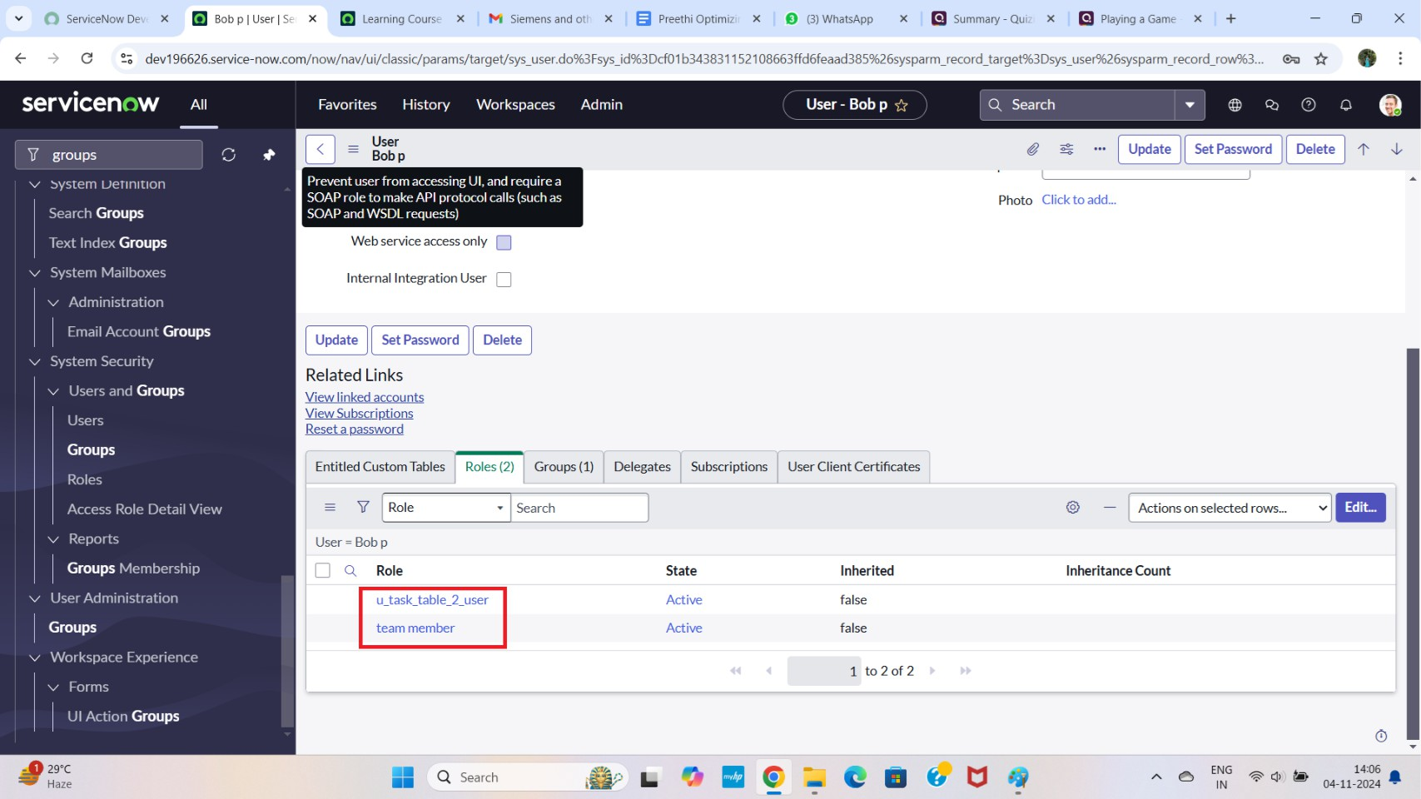

## Milestone 7 : Application access

**Activity 1: Assign table access to application**

1. while creating a table it automatically create a application and module for that table
2. Go to application navigator search for search project table application
3. Click on edit module
4. Give project member roles to that application
5. Search for task table2 and click on edit application.
6. Give the project member and team member role for task table 2 application

**Smart**

# lnternz

...., Copy af template - Google Do X project on users,groups,mles I **X Q** S.erviceNow Developers **X [i1** project table I Application Mer X +

f- C GI dev196626.ser\lice-now.com/now/nav/ui/clas:sic/params/target/sys:_app_application.do%3Fsys_id%3O9705334f831152108663ffd6feaad362

Cl X

*

**SerViCenOW** All Favorites History Admin : Application Menu - project table i°'r 0. Search -.- @ (,) 0



LJ - project table

r::l= Application Menu



An application menu is a group of moclulesin the application navigator. Choose the roles that are required to access the appliu1tion and add or remove madules in the related list below.

* Tith: [ project table

Application Global

Active **fJ**

Restricts access to the specified roles. Otherwise, all userscan view the application menu when it is active.

Roles0

project member

Spec.ifles the menu cat Q_ry, which defines the navigation menu style.The default value is Custom Applications.

Category Custom Applications

Q @]

The text that appears in a tooltipwhen auser points to this.application menu

Hint Description



() L t1 O el eltP de

...., Copy of templ<1te - Google )( **0** ServiceNow Developers )( **[il** project t<1ble I Applic<1tion '- **X [il** t'lsk: t<1ble 21Applic<1tion *Iv',* )( 0 ChatGPT

f- C GI dev196626.ser\lice-now.com/now/nav/ui/clas.sic/params./target/sys:_app_application.do%3Fs.ys_id%30114bece3835992108663ffd6feaad3dc

• + Cl X

*

**SerViCenOW** All Favorites History Admin : Application Menu - task table 2 ir *Q_* Search ,.. @ (,) 0 @

Application Menu tasktable2

[]

..,... I I lit I L":'J

Active **fJ**



Restricts access to the specified roles. Otherwise, all users can view the application menu when it is active.

Roles0

u_task_table_2_user, project member, team member

Specifies the menu cat Q_ry, which defines the navigation menu style.The default value is Custom Applications.

Category Custom Applications.

The text that appears in a tooltipwhen auser points to this.application menu

Hint

Description

V Modules [ Order ... 1 Search

� � �

® - [ Adionso sele l:ed row/. te ...**1111**

## Milestone 8 :Access control list Activity 1: Create ACL

1. Open service now.
2. Click on All >> search for ACL
3. Select Access Control(ACL) under system security
4. Click on elevate role
5. Click on new

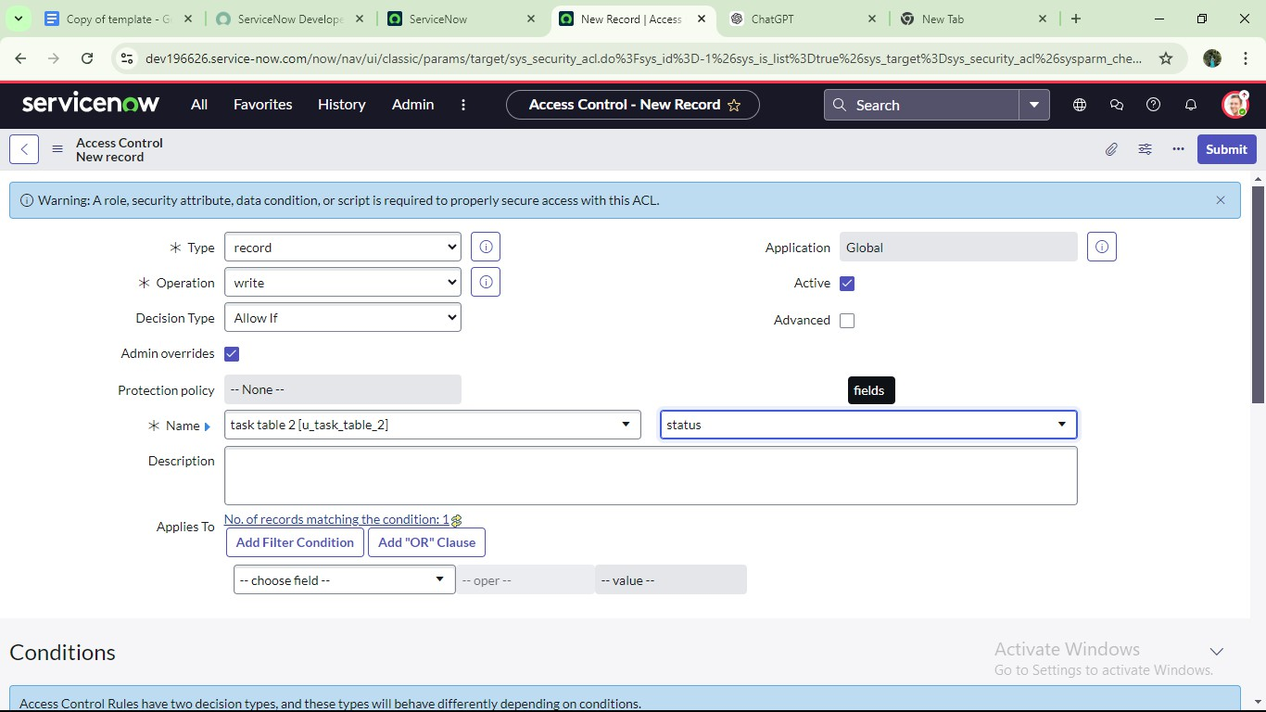

1. Fill the following details to create a new ACL
2. Scroll down under requires role
3. Double click on insert a new row
4. Give task table and team member role
5. Click on submit
6. Similarly create 4 acl for the following fields

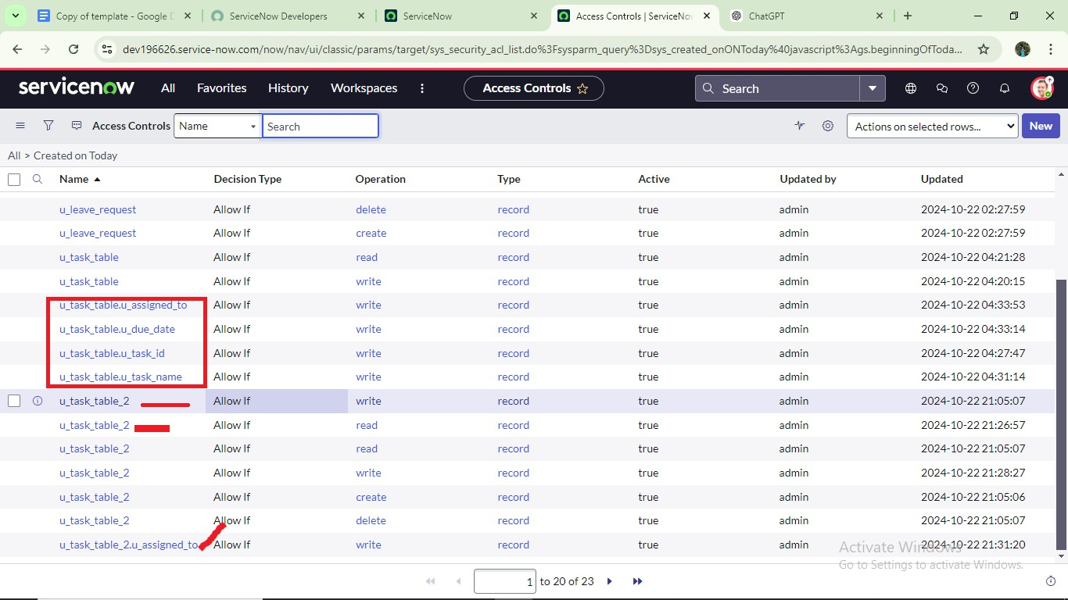

1. Click on profile on top right side
2. Click on impersonate user
3. Select bob user
4. Go to all and select task table2 in the application menu bar
5. Comment and status fields are have the edit access

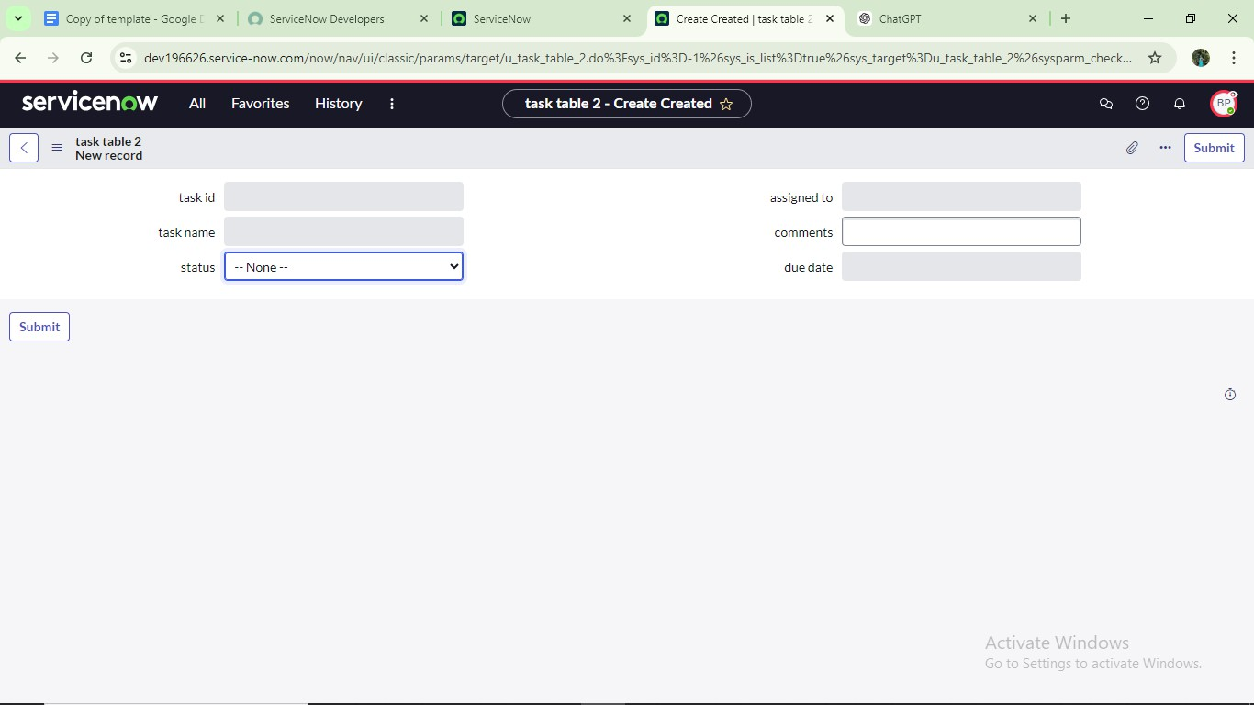

**Milestone 9: Flow**

## Activity 1: Create a Flow to Assign operations ticket to group

1. Open service now.
2. Click on All >> search for Flow Designer
3. Click on Flow Designer under Process Automation.
4. After opening Flow Designer Click on new and select Flow.
5. Under Flow properties Give Flow Name as “ task table”.
6. Application should be Global.
7. Click build flow.

**Smart**

# lnternz

...., Project on use' **X O** ServiceNow De **X [iJ** S.erviceNow **X [iJ** taslctablelWo **X [il** Cre;ited 2024-1 X @ Ch<1tGPT  **X** + Cl X

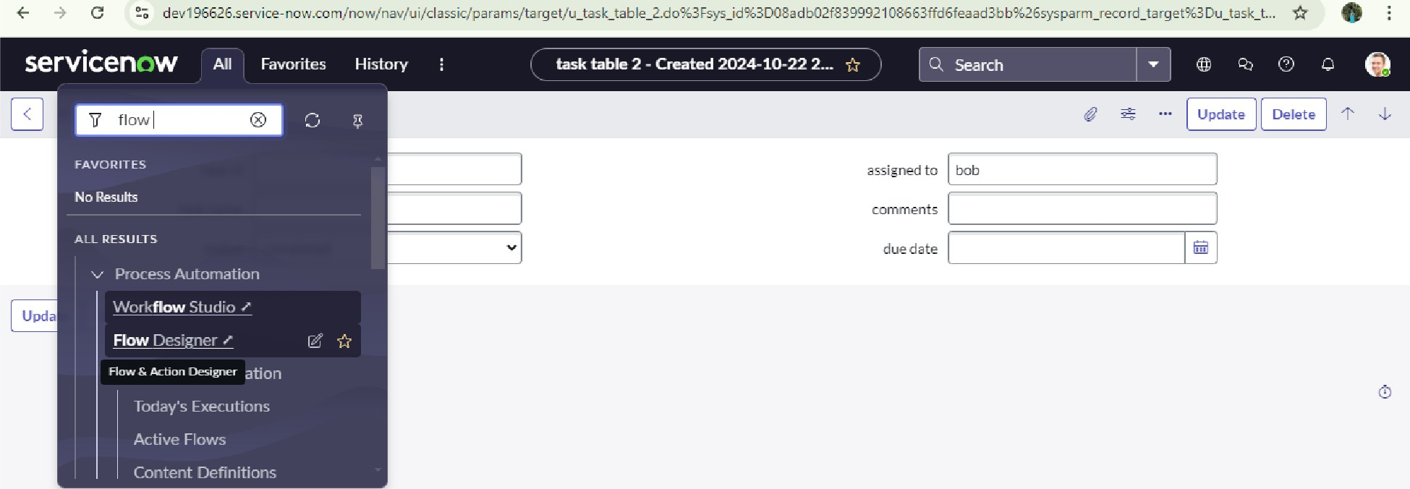

https://d 196626,seNict-now.com/$flow-d sign r.do?a;y parm-_nos-t3C-k=tr-ue

**Ac ,v.at, *w·* Cows**

() L t1

...., Project on use' **X O** ServiceNow De **X [iJ** S.erviceNow **X [iJ** Homepage - Fl **X [il** Cre;ited 2024- X @ Ch<1tGPT  **X** + Cl X

f- C -o dev196626.ser\lice-now.com/now/workflow-studio/tiome/flow *

0 Workflow Studio b: : s - t x

**A** Homepage l:,,;;i Operations *tP* Integrations

boo_§) - flo0 ( Actions ) cision tabB

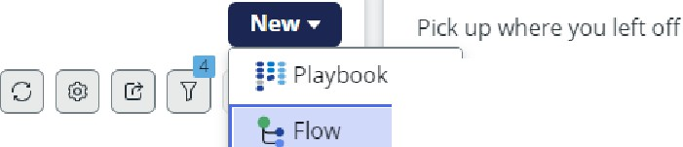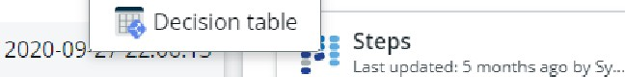

task table

Last updated: 14 min. .irigo by Sy,;t...

Active

**Update**

**t,** Subflow

**C Action**

Create Flow Data

Last updated: 5 months .ago by Sy...

true

2024-09

true

Flows 39

Last rcfresh.edjust now

□ Name .... Application Status

Benchmark Recommendation

Evaluator

Benchmarks Spoke Publi!fo,,d

Business process approval flow Global Published

Change - Cloud Infrastructure - Global Published true Authorize

2020-11-11 07:08:05

Latest updates

|  |  |  |  |  |
| --- | --- | --- | --- | --- |
| Change - Emergency Authorize | Global | Publi,;hed | true | 2020-10-06 05:39:49  System Administrator modified |
| Change- Emergency- Implement | Global | Publi,;hed | true | 2020-09-23 05:06:26 task table  14 min. ago |
| Change - Emergency- Review | Global | Published | true | 2020-10-27 04:18:08 •- System Administrator modified |
| Change - Normal - Assess | Global | Published | true | Create Flow Data  2020-10-06 05:37:05 5months ago |
| Change - Normal -Authorize | Global | Published | true | 2020-10-06 05:38:35 •· Syste11> i\clrti/niil.(@tos modified  :WP:S *e* "" ale |
| Change- Normal- Implement | Global | Published | true | 5monthsago  2020-09-23 04:23:59 |

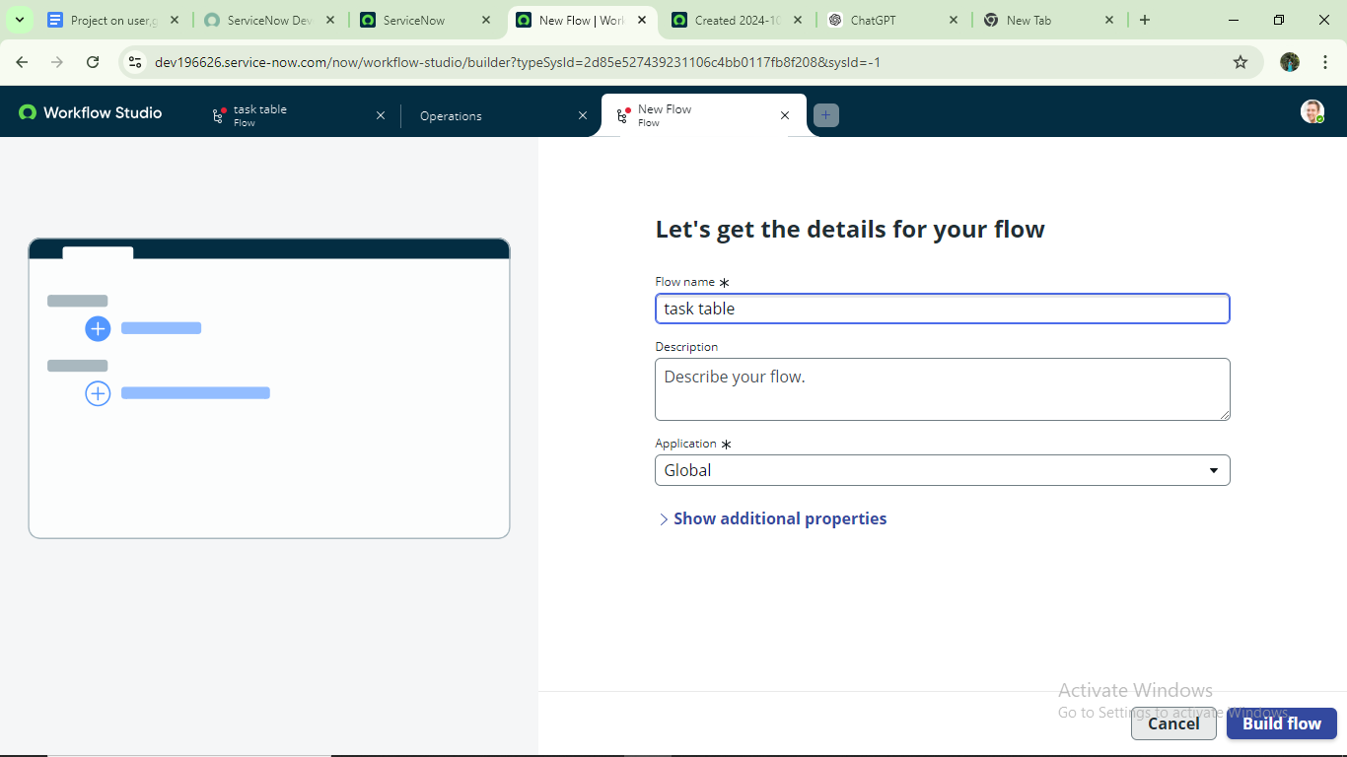

### next step:

1. Click on Add a trigger
2. Select the trigger in that Search for “create record” and select that.
3. Give the table name as “ task table ”.
4. Give the Condition as Field : status Operator :is Value : in progress

Field : comments Operator :is Value : feedback Field : assigned to Operator :is Value : bob

1. After that click on Done.

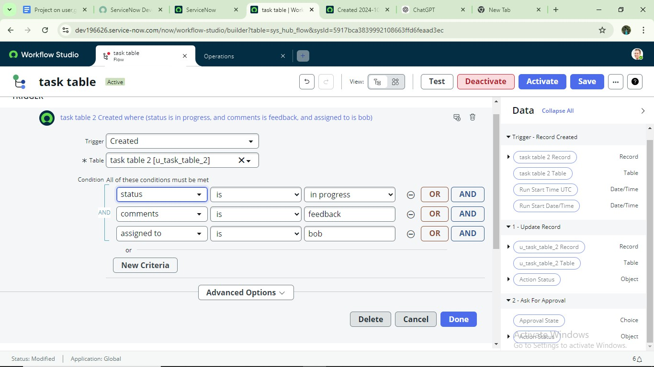

### Next step:

1. Click on Add an action.
2. Select action in that ,search for “ update records”.
3. In Record field drag the fields from the data navigation from Right Side(Data pill)
4. Table will be auto assigned after that
5. Add fields as “status” and value as “completed”
6. Click on Done.

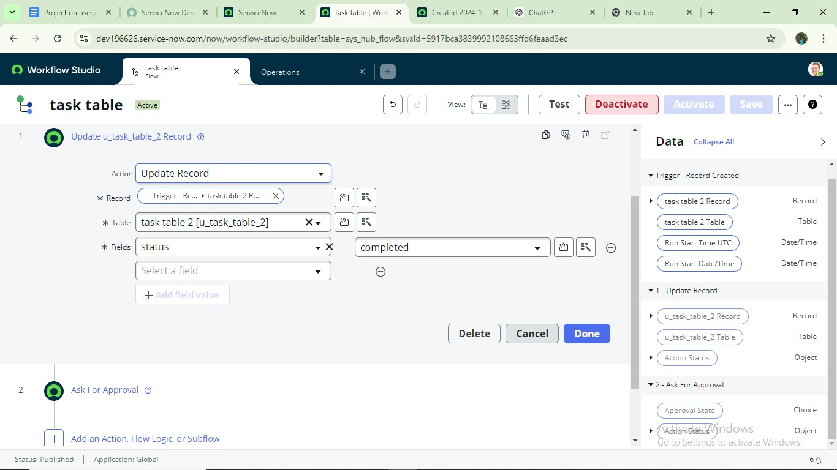

### Next step:

1. Now under Actions.
2. Click on Add an action.
3. Select action in that ,search for “ ask for approval ”.
4. In Record field drag the fields from the data navigation from Right side
5. Table will be auto assigned after that
6. Give the approve field as “ status”
7. Give approver as alice p
8. Click on Done.

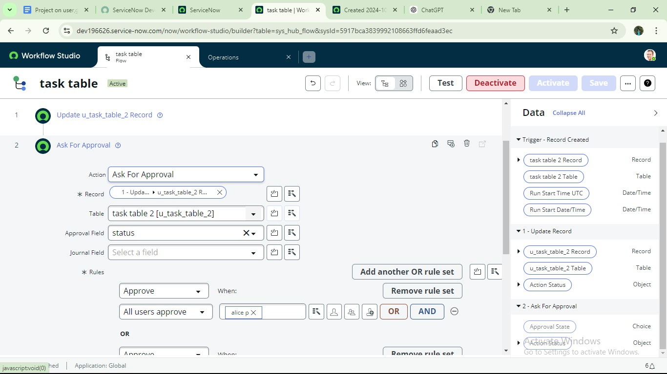

1. Go to application navigator search for task table.
2. It status field is updated to completed

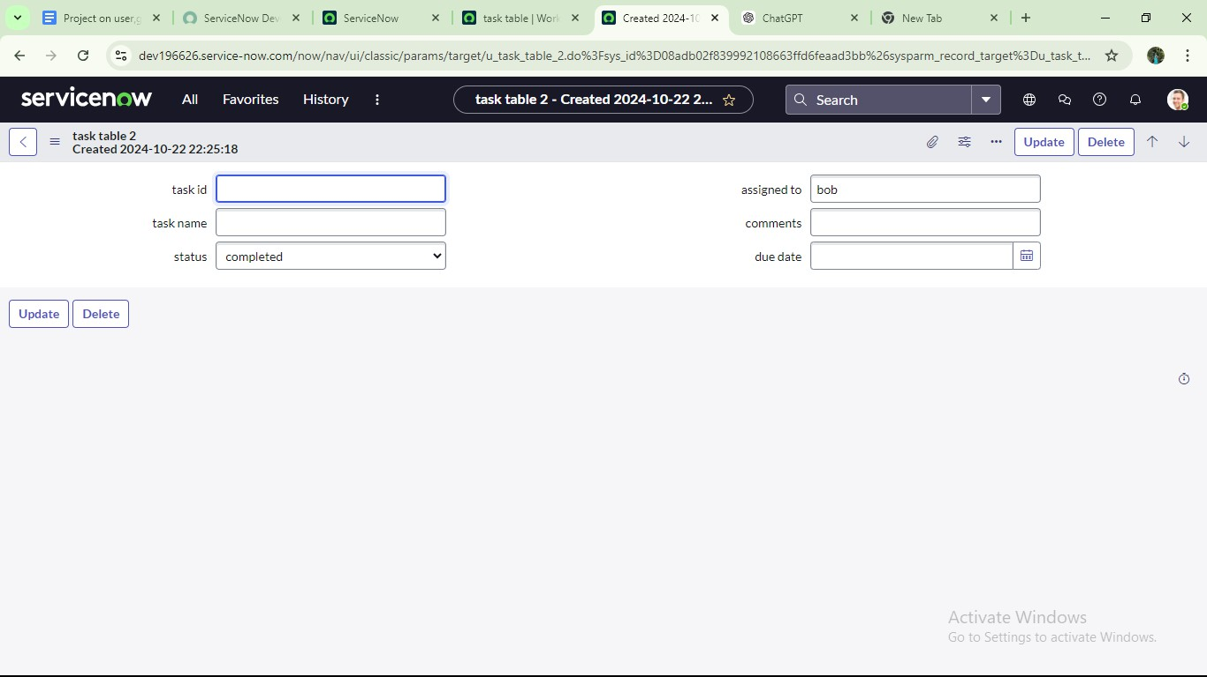

1. Go to application navigator and search for my approval
2. Click on my approval under the service desk.
3. Alice p got approval request then right click on requested then select approved

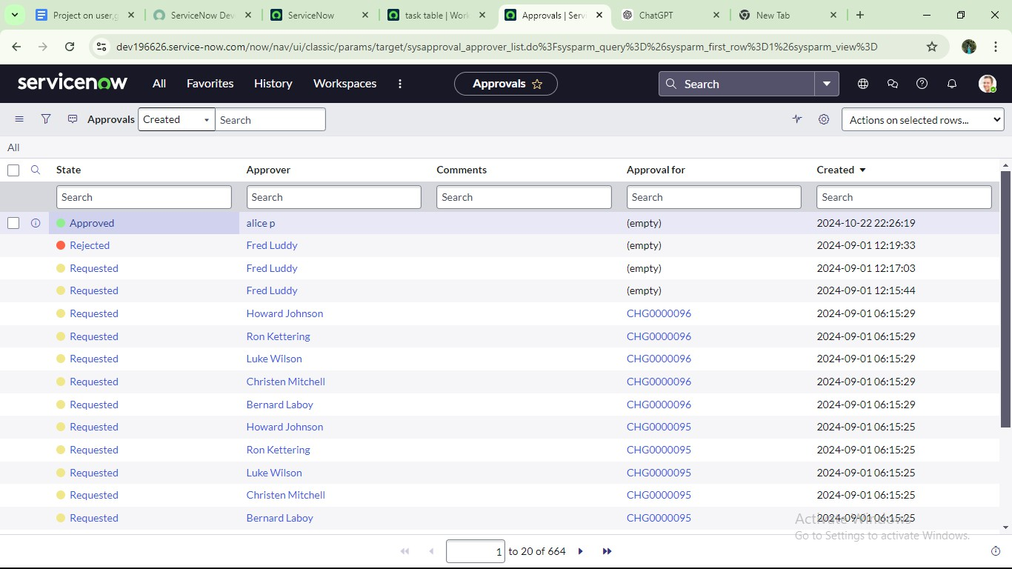

## Conclusion :

This scenario highlights a structured approach to project management, showcasing the roles of Alice and Bob within a defined workflow. With Alice's oversight and Bob's execution, the team effectively collaborates to ensure project success. The use of tables organizes key information, facilitating easy tracking of projects, tasks, and progress updates. Overall, this system promotes accountability, enhances communication, and leads to the successful completion of projects.